# LEARN YOUR PROPERTY’S FLOOD RISK

[Hurricanes, tropical storms, slow-moving rainstorms, monsoon rains] can create serious water runoff [levee overtopping] and [river, coastal flooding problems] in [community name]. The result is frequent and costly flooding. This can happen not only in high-risk areas, but also in moderate- to low-risk areas. About 40% of all flood insurance claims come from lower-risk areas.

The [county’s/community’s] new digital flood maps show flood risks property by property. Risk levels help decide building and flood insurance requirements. Go to [enter local URL or [MSC.FEMA.gov](https://msc.fema.gov/)] to view the maps and learn your risk. *[Include if applicable*: You can pull up the map that shows your property. Just enter your address].

**Questions about FEMA’s Region 6 Risk Mapping, Assessment, and Planning (Risk MAP) program?**

Visit [www.fema.gov/about/organization/region-6](http://www.fema.gov/about/organization/region-6).

**Questions about flood insurance?**

Visit [www.FloodSmart.gov](http://www.floodsmart.gov/), or speak with your insurance agent.

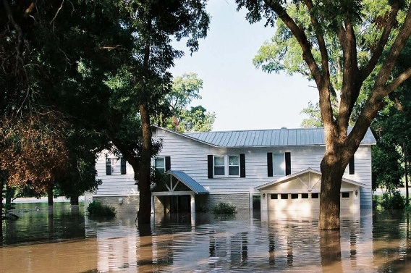

Flooding occurs in all 50 states and is the nation’s most costly natural disaster.

# FROM PRELIMINARY RELEASE TO EFFECTIVE DATE

New flood maps are set to become effective in [month/season (e.g., fall 2024)]. At that time, any related flood insurance requirements will also take effect. The map adoption process includes community meetings and a review of citizen concerns. Some property owners now shown to be in a high-risk zone may feel that their home or business sits high enough that it is not at high risk. An owner wishing to challenge the new designation must prove the structure is sufficiently above the elevation at which a major flood would reach (known as the Base Flood Elevation [BFE]). For more details on the appeals and comment process, visit [URL where appeal/comment information is available].

**MAPPING MILESTONES**

[DATE] — Preliminary flood maps released

[DATE] — Open House Held; Public Review

[DATE] — Start of [90-day] Public Comment Period [(for filing of appeals and comments)]

[Target Date, Month or Season – e.g., fall 2024]* — New flood maps take effect; new flood insurance requirements also take effect.

**Visit:** [www.fema.gov/about/organization/region-6](http://www.fema.gov/about/organization/region-6)[or local URL]to learn more about the mapping process and where and when meetings may be held.

**For General Information, Call:**

The [name of local call center or contact number] at [phone #].

Open [enter hours of operation].

*\* Date subject to change pending completion of review process*

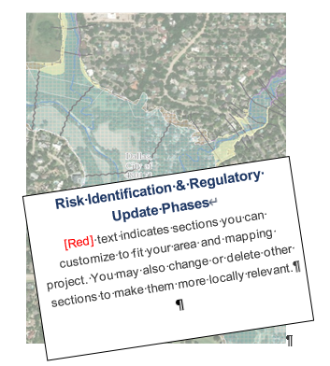

**IDENTIFYING FLOOD RISK**

New Flood   
Hazard Maps for

[county/community name]

***What property owners   
should know***

**IDENTIFYING THE RISK**

Flood risks vary from neighborhood to neighborhood and even property to property, and they can change over time. The likelihood of flooding in some areas increased due to new development and environmental changes.

|  |  |
| --- | --- |
| **If Flood Maps Show…** | **These Requirements, Options, and Savings Apply** |
| **Change from moderate or low flood risk to high risk (Zone B, C, or X to Zone A, AE, AH, AO, [V or VE])** | **Flood insurance is mandatory.** Flood insurance will be federally required for most mortgage holders. Insurance costs may rise to reflect the true (high) risk.  **Rating Options can offer savings.** The NFIP offers a Newly Mapped discount if a policy is in place within 12 months after a new flood map becomes effective. Premiums will then increase no more than 18% each year. |
| **[Change from high-risk Zone A or AE to higher-risk Zone V or VE; change in BFE]** | **[Flood zones and BFEs are not used in rating an NFIP policy. This means there would be no change in premium when the map changes.]** |
| **Change from high flood risk to moderate or low risk (e.g., flood Zone [V, VE], A, AE, AH, AO, to Zone X or shaded X)** | **Flood insurance is optional but recommended. The risk has only been reduced, not *removed*.** Because flood zones are not used in rating, there should be no change in premium due to the map change. However, maintaining flood insurance is still encouraged. About 40% of all flood insurance claims and 1/3 of flood disaster claims come from moderate-to low-risk areas.  Note that lenders always have the option to require flood insurance in these areas. |
| **No change in risk level** | **No change in insurance rates. However, this is a good time to review coverage with your insurance agent and ensure building and contents are adequately insured.** |

New detailed, digital flood hazard maps [are being/have been] developed to show current risk levels for [community name]. The new maps, known as Flood Insurance Rate Maps, replace maps that are based on outdated studies. Planners, local officials, engineers, and builders will use the new maps to help determine where and how to safely build new structures and developments. Residents and business owners can use the maps to learn their flood risk and determine the financial and physical steps they need to take to reduce potential damage and loss from a flood**.**

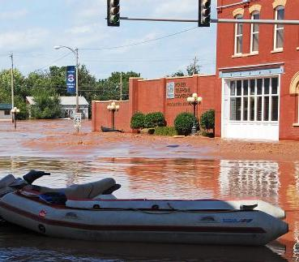

1*A BFE is the level that floodwaters have a*

*1%-annual-chance of reaching or exceeding  
 in any given year.*

# FLOOD MAPS AND FLOOD INSURANCE

With the release of the new flood hazard maps, some property owners will learn their flood risk is higher or lower than the previous maps showed. Others may discover that their Base Flood Elevation (BFE) changed. Certain changes in risk level can affect what you pay for flood insurance. The National Flood Insurance Program (NFIP) offers federally underwritten flood insurance that helps homeowners, business owners, and renters repair or replace buildings and their contents after a flood.

If you have a loan through a federally regulated or insured lender and are in a high-risk area (flood zones labeled with letters beginning with A [or V]), the federal government requires you to carry flood insurance as a condition of your loan.

If your property is newly shown to be in a high-risk area, the NFIP offers a rating option to help reduce your cost. But don’t wait until the new flood maps become effective to buy a flood insurance policy since you are at a high risk now. The chart below helps explain your options.