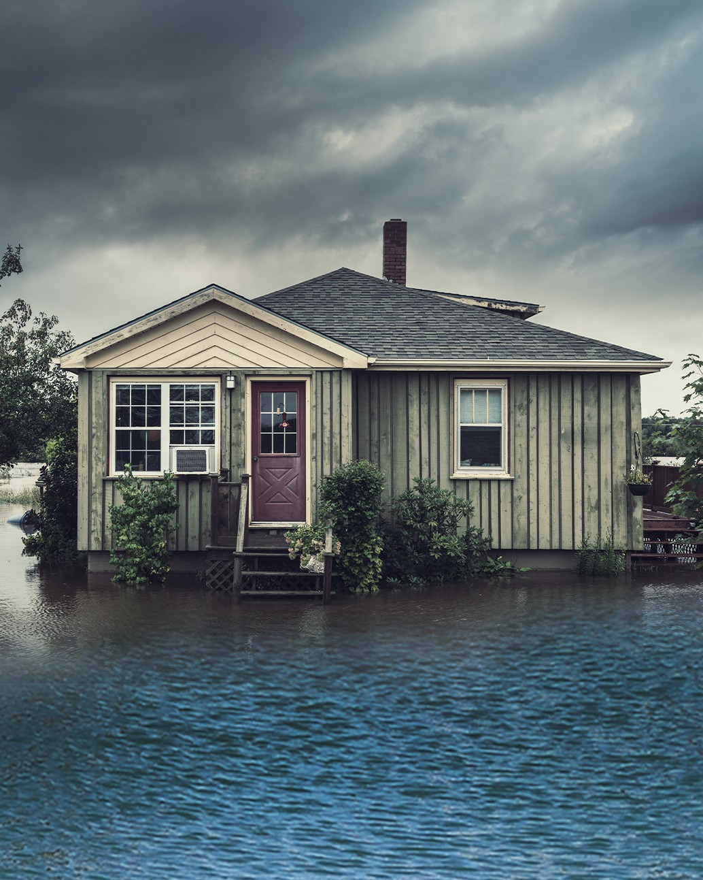

DO YOU KNOW YOUR

FLOOD RISK?

Attend the Upcoming Flood Risk Open House and Learn More

[DATE, TIME]
__________________________________________
[LOCATION]
__________________________________________
[ADDRESS #1]
__________________________________________
[ADDRESS #2]
__________________________________________
[CITY, STATE, ZIP]
__________________________________________
Join [COMMUNITY/COUNTY] for an opportunity to view the newly updated flood maps.
- Find your property on the new flood maps; learn your current flood risk.
- Get answers to your questions from
[COMMUNITY/COUNTY and FEMA REPRESENTATIVES].
- Learn about flood insurance from the experts.
- Get information on how the newly updated maps may impact insurance and building requirements.
- Hear about potential cost savings.
Open House Postcard – Post-Preliminary Phase

Language in [red] highlight areas indicates where you can customize text to be appropriate for your area and mapping project; however, you may also change/delete other non-highlighted parts of the document to make it relevant to your area and project.

[PROPERTY OWNER]
___________________________________
[STREET ADDRESS #1]
___________________________________
[STREET ADDRESS #2]
___________________________________
[CITY, STATE, ZIP]
___________________________________
Language in [red] highlight areas indicates where you can customize text to be appropriate for your area and mapping project; however, you may also change/delete other
non-highlighted parts of the document to make it relevant to your area and project.
…………………………………………………………….
For more information, visit [LOCAL URL OR
www.fema.gov/about/organization/region-6] or call
[COMMUNITY/COUNTY OFFICE NUMBER].

