New Jersey Wildfire Risk Assessment

(Excerpt from New Jersey State Hazard Mitigation Plan, pp. 330-341)

Appendix B, Section 4. Fires

Forest Fires
Although usually associated with the urbanized east, forest fires are not an uncommon occurrence in New Jersey, especially in the Pine Barrens (Figure 3-1 Physiographic Provinces and Location of the Ramapo Fault). Fires which burn more than 1,000 acres of forest occur on average approximately once every 10 years in the Pine Barrens. Although many plants in the Pine Barrens ecosystem rely on fire for a part of their reproductive cycle, the homes and property of the people who live there do not. Although Pinelands fires generally do not cause casualties, property loss can amount to thousands of dollars for each fire. Often, State roads are closed because of dangerous smoke conditions. Emergency responders are often needed to reroute traffic and control the fires.
Fire has been a major factor in New Jersey’s environment since prehistoric times. Natural fires and Native American burning played a major role in shaping the land and providing the vast expanses of forestland that greeted early settlers. These settlers soon realized that the Pinelands of New Jersey is one of the most hazardous fuel types in the nation, as best characterized in a report from 1755 describing a wildfire 30 miles long from Barnegat to Little Egg Harbor.
The reasons for New Jersey’s continuing wildfire problem are many and varied. However, the major contributing factors, or what could be termed the “Wildfire Equation,” can be grouped into the two broad areas of hazard and risk. Hazard + Risk = Wildfire Probability.
A hazard is what burns! The New Jersey Pinelands is a fire adapted forest community that takes advantage of wildfire to reproduce. This Forest community is one of the most hazardous wildland fuel types in the nation. The Pinelands are classified as Fuel Model B of the National Fire Danger Rating System with California chaparral and a number of other high hazard types. Fuel loadings exceed twenty tons per acre in some locales. This has been equated to having an inch of gasoline covering all of south and central New Jersey. Pinelands fires burn extremely hot and spread rapidly. Crown fires are fairly common, spreading from treetop to treetop, as is long range spotting where flying embers start new fires in advance of the main fire.
Risk is what causes fires. In New Jersey, 99% of all forest fires are caused by people, either through carelessness or intentional acts. New Jersey’s high population density has created land use pressures in which more people are moving from urban areas to build homes in rural wildland areas. With more people living in, and enjoying the state’s wildlands for various forms of recreation, the number of fire starts and the seriousness of their consequences increases.
A potentially explosive combination is created when the factors of hazardous wildland fuels, interface home development, and an increased risk of human caused ignition come together under extreme fire weather conditions. The following is a list of some significant wildfires that have occurred during the last 50 years.
1954- A 20,000- acre wildfire threatened the town of Chatsworth.
1963- A series of 37 major wildfires burned 193,000- acres during the period of April 20 through 22. 186 homes and 197 buildings were destroyed and 7 people were killed. $8.5 million in property damage was reported. These 1963 conflagrations are often cited as a benchmark for wildfire and wildland/urban interface comparisons in the United States.
1971- The Manahawkin fire burned 21,00- acres in 7 hours, 13 minutes.
1977- A 15,000 acre wildfire burned six homes and caused extensive damage. Four volunteer firefighters were killed during a 2,300-acre fire in Bass River.
1992- A series of four major wildfires burned 14,000- acres on May 3rd closing the Garden State Parkway and forced a shutdown of the Oyster Creek Nuclear Facility.
1995- On April 4th, a 19,225-acre fire burned through Manchester, Lacey, and Ocean Townships in Ocean County.
1997-The Wrangle Brook Fire on July 19 burned 702-acres and threatened over 300 homes in the retirement community of Holiday City, Berkeley Township, damaging 20. On July 29, an additional 1918-acres were burned in Hammonton and Mullica Townships on the Rockwood fire which threatened the community of Totem Village.
1999- The Bass River fire burned 11,975- acres in Burlington County.
2001- Several major fires occurred this year including the 765-acre Airport Fire evacuating 60 homes and the 151-acre Cheesequake Creek Fire evacuating 25 homes in April, and the Warren Grove Fire destroying 1,600- acres in June.
2002- The Jake’s Branch Fire was started in a remote portion of Berkeley Township and before it was controlled at 1,277- acres it destroyed 3 homes and 15 outbuildings, seriously damaged an additional 18 homes and outbuildings, and forced the evacuation of 500 residences in the community of Beachwood. This fire also closed the Garden State Parkway between 3pm June 2, and 2am June 3, 2002.

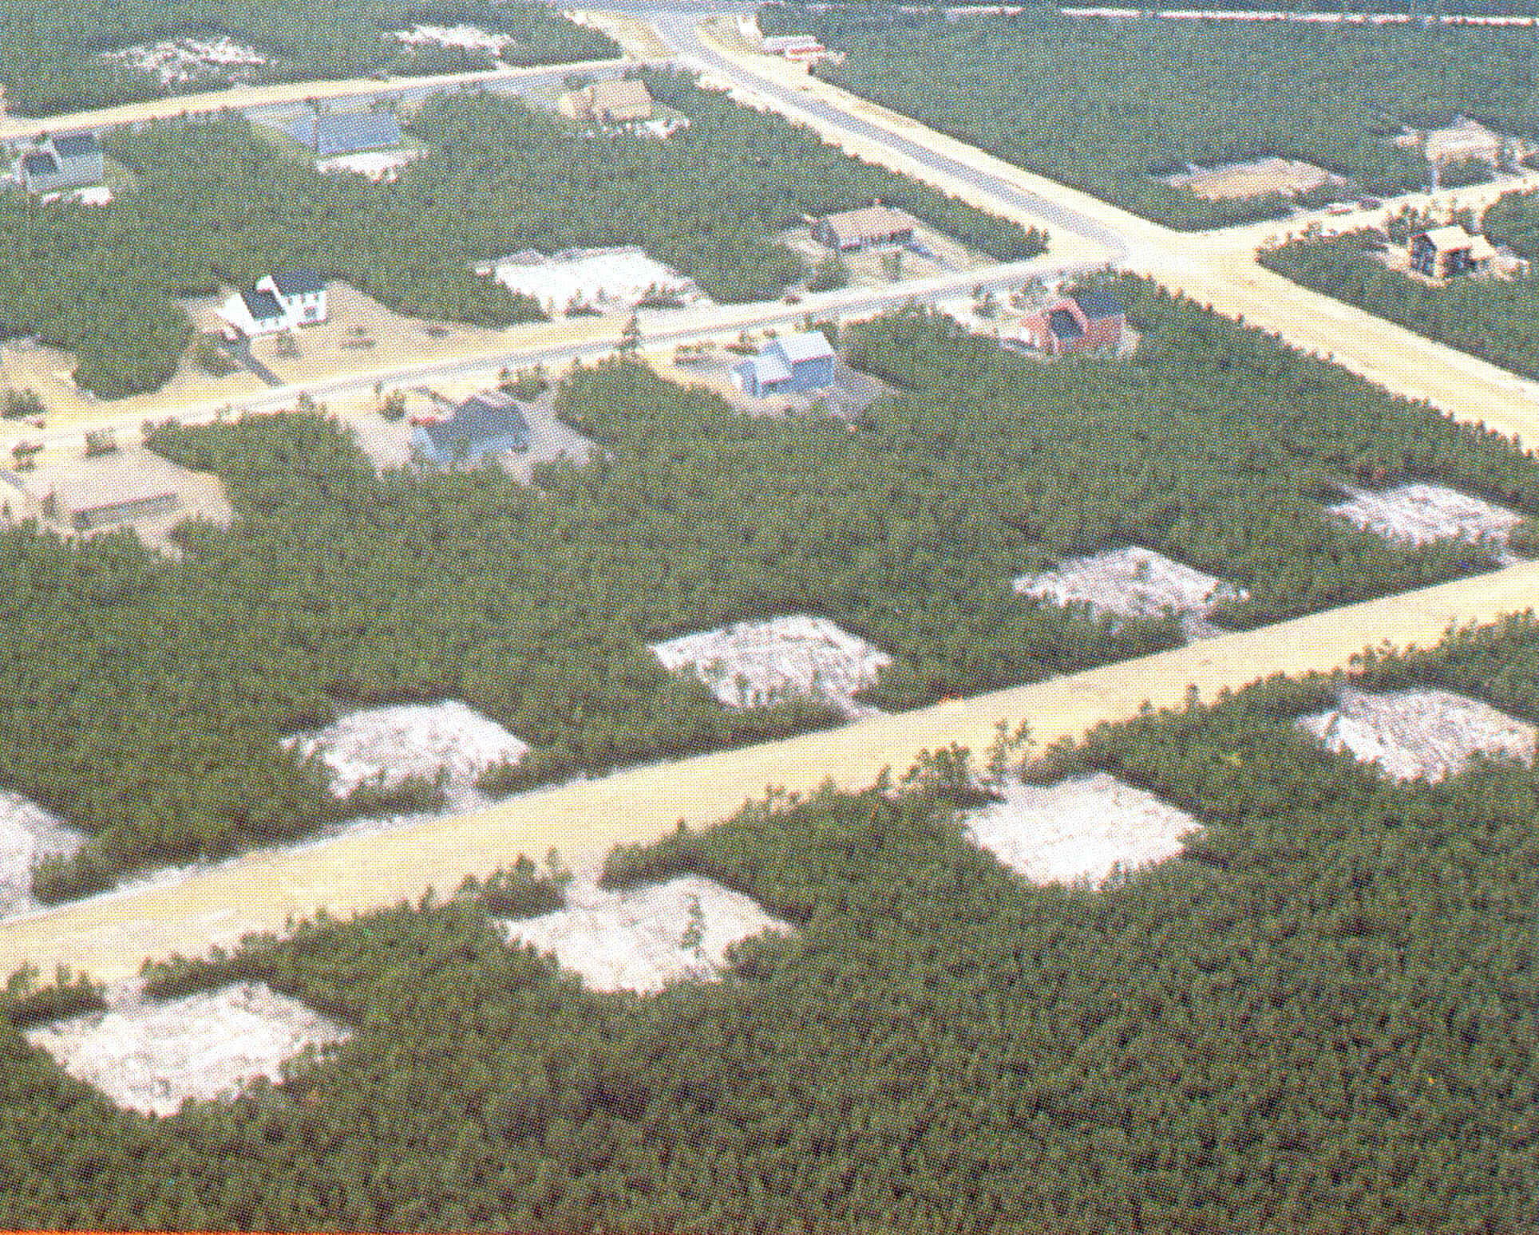
Wildland/Urban Interface in the NJ Pinelands
Number of Incidents per Year by County*
County | 1993 | 1994 | 1995 | 1996 | 1997 | 1998 | 1999 | 2000 | 2001 | 2002 | 2003 | Totals | 10 Year Average | Rank
Atlantic | 219 | 171 | 226 | 126 | 214 | 224 | 206 | 155 | 232 | 250 | 163 | 2186 | 219 | 2
Bergen | 15 | 9 | 5 | 1 | 7 | 8 | 8 | 6 | 13 | 4 | 5 | 81 | 8 | 17
Burlington | 141 | 141 | 154 | 99 | 121 | 133 | 140 | 88 | 128 | 109 | 64 | 1318 | 132 | 4
Camden | 57 | 86 | 110 | 55 | 138 | 126 | 145 | 124 | 143 | 103 | 45 | 1132 | 113 | 6
Cape May | 48 | 72 | 129 | 59 | 86 | 71 | 84 | 50 | 92 | 80 | 40 | 811 | 81 | 9
Cumberland | 151 | 152 | 191 | 93 | 151 | 206 | 173 | 100 | 140 | 102 | 58 | 1517 | 151 | 3
Gloucester | 18 | 50 | 77 | 34 | 67 | 53 | 72 | 36 | 73 | 78 | 23 | 581 | 58 | 11
Hunterdon | 55 | 32 | 72 | 21 | 37 | 28 | 69 | 44 | 66 | 41 | 26 | 491 | 49 | 15
Mercer |  | 3 | 2 |  |  |  | 5 |  | 4 | 26 | 8 | 48 | 5 | 18
Middlesex | 65 | 51 | 70 | 18 | 54 | 50 | 87 | 62 | 106 | 106 | 41 | 710 | 71 | 10
Monmouth | 63 | 51 | 48 | 30 | 30 | 34 | 50 | 35 | 75 | 54 | 42 | 512 | 51 | 13
Morris | 146 | 84 | 137 | 62 | 113 | 99 | 139 | 58 | 65 | 87 | 63 | 1053 | 105 | 7
Ocean | 355 | 313 | 452 | 196 | 347 | 304 | 412 | 265 | 374 | 287 | 227 | 3532 | 353 | 1
Passaic | 51 | 51 | 66 | 17 | 37 | 50 | 71 | 29 | 61 | 39 | 21 | 493 | 49 | 14
Salem | 24 | 32 | 76 | 22 | 36 | 47 | 24 | 10 | 38 | 37 | 15 | 361 | 36 | 16
Somerset | 79 | 97 | 55 | 6 | 50 | 17 | 65 | 15 | 50 | 86 | 41 | 561 | 56 | 12
Sussex | 52 | 67 | 87 | 38 | 137 | 109 | 176 | 85 | 162 | 129 | 102 | 1144 | 114 | 5
Warren | 54 | 60 | 64 | 33 | 56 | 94 | 129 | 75 | 90 | 144 | 55 | 854 | 85 | 8
Total | 1593 | 1522 | 2021 | 910 | 1681 | 1653 | 2055 | 1237 | 1912 | 1762 | 1039 | 17385 | 1738
*The number of incidents includes only those wildfires to which the NJ Forest Fire Service responded to in its designated response area. Numbers are rounded for clarity.

Number of Acres Burned per Year by County*
County | 1993 | 1994 | 1995 | 1996 | 1997 | 1998 | 1999 | 2000 | 2001 | 2002 | 2003 | Total | 10 Year Average | Rank
Atlantic | 56 | 277 | 317 | 130 | 2150 | 136 | 188 | 189 | 166 | 206 | 88 | 3904 | 390 | 3
Bergen | 5 | 12 | 17 | 0.25 | 49 | 42 | 103 | 8 | 98 | 10 | 2 | 348 | 35 | 17
Burlington | 133 | 372 | 142 | 130 | 282 | 121 | 12857 | 340 | 215 | 57 | 26 | 14677 | 1468 | 2
Camden | 42 | 12 | 113 | 61 | 265 | 220 | 171 | 283 | 279 | 806 | 382 | 2744 | 274 | 6
Cape May | 38 | 39 | 126 | 33 | 69 | 30 | 54 | 178 | 60 | 32 | 26 | 684 | 68 | 13
Cumberland | 94 | 187 | 265 | 149 | 138 | 222 | 290 | 514 | 994 | 78 | 50 | 2982 | 298 | 4
Gloucester | 8 | 59 | 99 | 44 | 134 | 117 | 173 | 36 | 110 | 111 | 12 | 905 | 90 | 10
Hunterdon | 12 | 45 | 408 | 7 | 38 | 44 | 108 | 12 | 30 | 21 | 7 | 733 | 73 | 12
Mercer |  | 17 | 2 |  |  |  | 4 |  | 60 | 19 | 1 | 104 | 10 | 18
Middlesex | 17 | 288 | 122 | 26 | 99 | 145 | 196 | 78 | 279 | 118 | 124 | 1492 | 149 | 7
Monmouth | 11 | 58 | 26 | 81 | 22 | 30 | 33 | 20 | 30 | 24 | 18 | 353 | 35 | 16
Morris | 57 | 77 | 122 | 58 | 422 | 37 | 102 | 25 | 52 | 63 | 42 | 1057 | 106 | 9
Ocean | 179 | 567 | 19777 | 136 | 1023 | 138 | 712 | 123 | 1806 | 4089 | 109 | 28661 | 2866 | 1
Passaic | 59 | 56 | 90 | 32 | 18 | 35 | 77 | 16 | 24 | 16 | 32 | 452 | 45 | 14
Salem | 11 | 88 | 416 | 58 | 74 | 62 | 37 | 40 | 19 | 30 | 6 | 840 | 84 | 11
Somerset | 8 | 78 | 22 | 2 | 30 | 6 | 164 | 5 | 43 | 32 | 9 | 399 | 40 | 15
Sussex | 14 | 589 | 94 | 17 | 69 | 62 | 84 | 99 | 165 | 112 | 28 | 1334 | 133 | 8
Warren | 7 | 36 | 1565 | 51 | 23 | 20 | 1058 | 98 | 32 | 43 | 6 | 2940 | 294 | 5
Total | 754 | 2968 | 23721 | 1016 | 4905 | 1469 | 16410 | 2064 | 4462 | 5866 | 966 | 64609 | 6461

*The number of incidents includes only those wildfires to which the NJ Forest Fire Service responded to in its designated response area. Numbers are rounded for clarity.

“Major” Fires per County, 1993 - 2003
YEAR |  | NUMBER OF ACRES BURNED |  | COUNTY
1993 |  | 120 |  | OCEAN
1994 |  | 500 |  | SUSSEX
1994 |  | 223 |  | BURLINGTON
1994 |  | 201 |  | MIDDLESEX
1994 |  | 145 |  | OCEAN
1994 |  | 140 |  | OCEAN
1994 |  | 110 |  | ATLANTIC
1995 |  | 19225 |  | OCEAN
1995 |  | 100 |  | SALEM
1995 |  | 115 |  | ATLANTIC
1995 |  | 325 |  | HUNTERDON
1995 |  | 200 |  | OCEAN
1995 |  | 750 |  | WARREN
1997 |  | 100 |  | BURLINGTON
1997 |  | 150 |  | OCEAN
1997 |  | 702 |  | OCEAN
1997 |  | 1900 |  | ATLANTIC
1997 |  | 350 |  | MORRIS
1999 |  | 375 |  | WARREN
1999 |  | 100 |  | MIDDLESEX
1999 |  | 623 |  | WARREN
1999 |  | 11765 |  | BURLINGTON
1999 |  | 300 |  | BURLINGTON
1999 |  | 278 |  | OCEAN
1999 |  | 500 |  | BURLINGTON
2000 |  | 158 |  | CAPE MAY
2000 |  | 150 |  | BURLINGTON
2000 |  | 110 |  | CAMDEN
2000 |  | 350 |  | CUMBERLAND
2001 |  | 120 |  | CAMDEN
2001 |  | 151 |  | MIDDLESEX
2001 |  | 765 |  | CUMBERLAND
2001 |  | 1600 |  | OCEAN
2002 |  | 740 |  | CAMDEN
2002 |  | 1277 |  | OCEAN
2002 |  | 2600 |  | OCEAN
Low Hazard  Moderate Hazard  High Hazard  Extreme Hazard  Developed  Total State Acres | 1,550,642.01  1,123,490.32  665,356.10  428,318.69  927,754.85  4,695,561.97 |  | 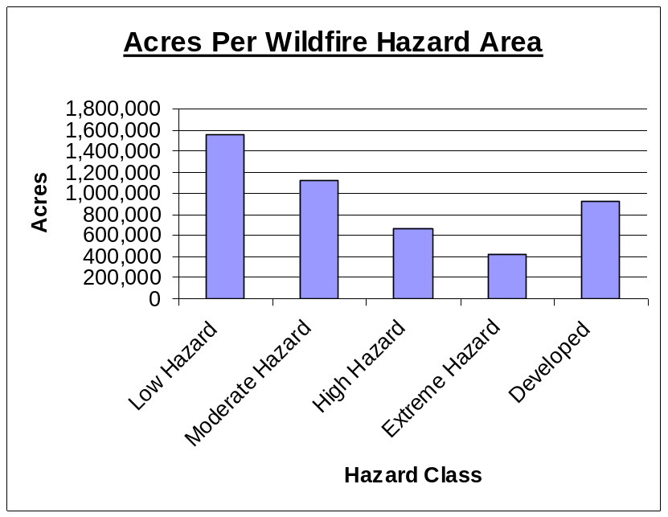

Figure 1: Jake's Branch Forest Fire Area Analysis
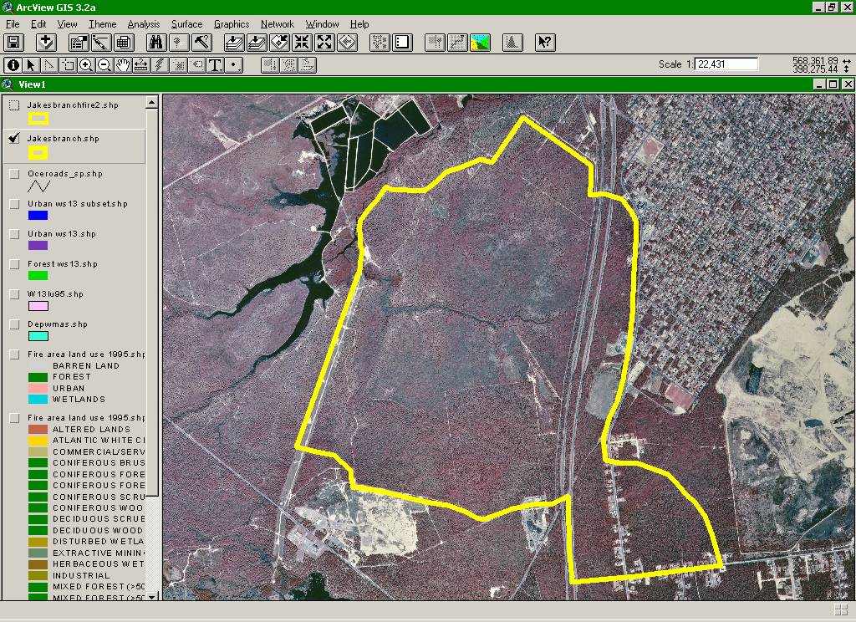
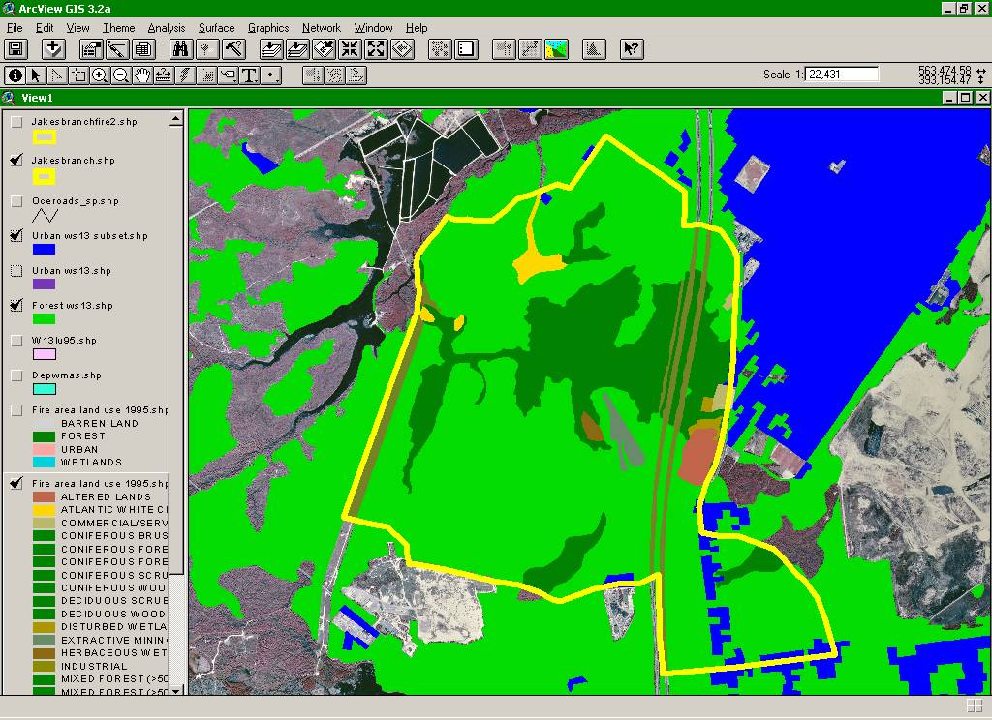
Although it is not necessary for a fire to be large to possess a serious threat or loss to homes and improved property, the NJ Forest Fire Service regard fires over 100-acres as “major”. Analysis of fire data for the last several years reveal trends that can help predict the probability of major fire events. It can be argued that the probability of wildfire events will follow the “average” year as long as neither significant weather changes nor human ignition factors become more severe.
Defining the potential losses by wildfires in New Jersey is difficult. Weather, the main influence on how a wildfire burns, is a variable that can only be predicted on a short- term basis. Actual dollar loss, therefore, will be specific to each wildfire and each year. During 2001, the latest year for which estimates were available, these losses to improved property totaled $266,025. Suppression costs to the state for that year totaled $955,907. Property losses for the 2002, Jakes Branch wildfire exceeded one million dollars. Other indirect losses must also be considered.
The primary forest product industry, in other words the actual harvest and processing of forest products, is limited within the state. Therefore, the value of timber products lost to wildfire is not recorded. Additionally, the dollar loss of the recreation experience to a forest visitor from a wildfire is subjective, as well as is the losses to commerce from the effects of road closures and evacuations in the area of the wildfire.
Using the data that can be found in the previous tables, the following information can be highlighted:
- The NJ Forest Fire Service has continued to meet its goal of limiting the number of fires to below 2000 annually.
- The Forest Fire Service has also kept the acreage lost to wildfire below its goal of 18,750.
- The probability exists that New Jersey will continue to face an average of three fires greater than 100- acres each year.
- Ocean County leads the state in the number of fires, total acreage, and number of fires greater than 100-acres. Burlington County follows closely behind.

Drought-Aggravated Forest Fires
In those years when drought was prevalent, wildfires were a major concern. Several large fires struck the Pine Barrens and other forested areas. Fire services have employed isolation and pre-burn techniques to limit the total acreage affected. This has had excellent results, and now that we are climbing out of drought conditions and groundwater tables are returning to better levels, our forest have rebounded well. Fire coordinators continue these programs throughout the dry season.
One of the most consistent and serious impacts of drought is the contribution to conditions conducive to forest fires. This applies particularly to the Pine Barrens, where drying conditions favor the combustion of forest fuels. Generally, a relative humidity of less than 40 percent, winds greater than 13 miles and hour, and precipitation of less than 0.01 inches during a month are ideal conditions for forest fires in the Pine Barrens. Given the proper conditions, stray cigarette butts, improperly extinguished campfires, and intentional matches can all start fires in the Pine Barrens. The season of greatest fire threat runs from March through May, though extensive fires have occurred in the summer and autumn months.
A complete forest fire hazards analysis for all State-owned lands has been prepared in a document published by the New Jersey Bureau of Forest Fire Management, of the Division of Parks and Forestry of the Department of Environmental Protection entitled the New Jersey Forest Fire Management Plan.

Industrial Fires
When an industrial facility catches fire, complications exist on top of complications. In addition to a fire fed by highly flammable chemicals, the smoke itself can be toxic. Using water to put out the fire can spread toxic chemicals into the soil and eventually the groundwater. Workers may suffer from chemical poisoning and need to be treated for exposure. However, because of the large number of chemicals on a site and their mixing during the fire, uncertainty may exist as to what workers were exposed. Because New Jersey still retains many of its chemical and manufacturing facilities, industrial fires do occur in the state.

Urban Fires
Fighting urban fires is often difficult, especially in older neighborhoods where homes were built to lower fire standards and more belongings which serve as fire fuel has collected in attics and basements. In addition, because of their close spacing and older, the drier nature of the buildings, urban environments are well known for multiple building fires because of spreading flames. In addition, intense development means higher traffic volumes, causing greater difficulty in reaching urban fires.

Fire Prevention and Responsible Agencies
Both the State and localities are responsible for fire data collection and analysis, "hot spot" identification, and mitigation development. As discussed earlier in this chapter under Drought-Aggravated Forest Fires, the State Forest Fire Hazard Reduction Plan sets out ways to suppress and mitigate forest fires. In addition, a full forest fire management plan titled the State Forest Fire Management Plan also prepared by the Bureau of Fire Management, further describes hazard areas, establishes authority and administration of forest fire management and fully explains the organization for fire suppression and mitigation for all of New Jersey-owned forest land.
Outside of forest lands, municipalities are responsible for fire management with State or county assistance on a per request basis.
Statistical data collection and hazard analysis for all fires in New Jersey is overseen and coordinated by the State Fire Marshals Office, Division of Fire Safety, Department of Community Affairs. The State Fire Marshal is New Jersey's administrator of all fire reporting to the United State Fire Administration (USFA), which is part of the Federal Emergency Management Agency (FEMA).
The State Fire Marshal is mandated by Governor's Executive Order 86 to collect and report all statistics on fires from the State Bureau of Forest Fire Management and all local fire companies and input the information into the National Fire Reporting System (NFIRS). Today, most fire incidents are reported into this database.
With most fires now recorded in the NFIRS, the State can now begin the process of analyzing where fires are most common, what their main causes are and what mitigation measures can be taken to prevent fires.

Fire Bibliography
United States Fire Administration, Federal Emergency Management Agency, "National Fire Incident Reporting System", 1999, Emmitsburg, Maryland
New Jersey Office of Emergency Management, Population Protection Planning Unit, New Jersey State Police, "Hazard Analysis New Jersey." 1984, Trenton, New Jersey

